A quick introduction to the Google C++ Testing Framework
Learn about key features for ease of use and production-level deployment
Google provides an interesting and easy-to-use open source alternative for developing unit tests to validate C/C++ based software. This article introduces readers to some of the more useful features of the Google C++ Testing Framework and is based on version 1.4 of the release.
http://www.ibm.com/developerworks/aix/library/au-googletestingframework.html
PDF (236 KB) - Arpan Sen (arpansen@gmail.com), Independent author - 11 May 2010

Why use the Google C++ Testing Framework?
There are many good reasons for you to use this framework. This section describes several of them.
Some categories of tests have bad memory problems that surface only during certain runs. Google's test framework provides excellent support for handling such situations. You can repeat the same test a thousand times using the Google framework. At the first sign of a failure, the debugger is automatically invoked. In addition, all of this is done with just two switches passed from command line: --gtest_repeat=1000 --gtest_break_on_failure.
Contrary to a lot of other testing frameworks, Google's test framework has built-in assertions that are deployable in software where exception handling is disabled (typically for performance reasons). Thus, the assertions can be used safely in destructors, too.
Running the tests is simple. Just making a call to the predefined RUN_ALL_TESTS macro does the trick, as opposed to creating or deriving a separate runner class for test execution. This is in sharp contrast to frameworks such as CppUnit.
Generating an Extensible Markup Language (XML) report is as easy as passing a switch: --gtest_output="xml:<file name>". In frameworks such as CppUnit and CppTest, you need to write substantially more code to generate XML output.

Creating a basic test
Consider the prototype for a simple square root function shown in Listing 1.

Listing 1. Prototype of the square root function
double square-root (const double);
For negative numbers, this routine returns -1. It's useful to have both positive and negative tests here, so you do both. Listing 2 shows that test case.

Listing 2. Unit test for the square root function
#include "gtest/gtest.h"

TEST (SquareRootTest, PositiveNos) {
EXPECT_EQ (18.0, square-root (324.0));
EXPECT_EQ (25.4, square-root (645.16));
EXPECT_EQ (50.3321, square-root (2533.310224));
}

TEST (SquareRootTest, ZeroAndNegativeNos) {
ASSERT_EQ (0.0, square-root (0.0));
ASSERT_EQ (-1, square-root (-22.0));
}
Listing 2 creates a test hierarchy named SquareRootTest and then adds two unit tests, PositiveNos and ZeroAndNegativeNos, to that hierarchy. TEST is a predefined macro defined in gtest.h (available with the downloaded sources) that helps define this hierarchy. EXPECT_EQ and ASSERT_EQ are also macros—in the former case test execution continues even if there is a failure while in the latter case test execution aborts. Clearly, if the square root of 0 is anything but 0, there isn't much left to test anyway. That's why the ZeroAndNegativeNos test uses only ASSERT_EQ while the PositiveNos test uses EXPECT_EQ to tell you how many cases there are where the square root function fails without aborting the test.

Running the first test
Now that you've created your first basic test, it is time to run it. Listing 3 is the code for the main routine that runs the test.

Listing 3. Running the square root test
#include "gtest/gtest.h"

TEST(SquareRootTest, PositiveNos) {
EXPECT_EQ (18.0, square-root (324.0));
EXPECT_EQ (25.4, square-root (645.16));
EXPECT_EQ (50.3321, square-root (2533.310224));
}

TEST (SquareRootTest, ZeroAndNegativeNos) {
ASSERT_EQ (0.0, square-root (0.0));
ASSERT_EQ (-1, square-root (-22.0));
}

int main(int argc, char **argv) {
::testing::InitGoogleTest(&argc, argv);
return RUN_ALL_TESTS();
}
The ::testing::InitGoogleTest method does what the name suggests—it initializes the framework and must be called before RUN_ALL_TESTS. RUN_ALL_TESTS must be called only once in the code because multiple calls to it conflict with some of the advanced features of the framework and, therefore, are not supported. Note that RUN_ALL_TESTS automatically detects and runs all the tests defined using the TEST macro. By default, the results are printed to standard output. Listing 4 shows the output.

Listing 4. Output from running the square root test
Running main() from user_main.cpp
[==========] Running 2 tests from 1 test case.
[----------] Global test environment set-up.
[----------] 2 tests from SquareRootTest
[ RUN ] SquareRootTest.PositiveNos
..\user_sqrt.cpp(6862): error: Value of: sqrt (2533.310224)
Actual: 50.332
Expected: 50.3321
[ FAILED ] SquareRootTest.PositiveNos (9 ms)
[ RUN ] SquareRootTest.ZeroAndNegativeNos
[ OK ] SquareRootTest.ZeroAndNegativeNos (0 ms)
[----------] 2 tests from SquareRootTest (0 ms total)

[----------] Global test environment tear-down
[==========] 2 tests from 1 test case ran. (10 ms total)
[ PASSED ] 1 test.
[ FAILED ] 1 test, listed below:
[ FAILED ] SquareRootTest.PositiveNos

1 FAILED TEST

Options for the Google C++ Testing Framework
In Listing 3 you see that the InitGoogleTest function accepts the arguments to the test infrastructure. This section discusses some of the cool things that you can do with the arguments to the testing framework.
You can dump the output into XML format by passing --gtest_output="xml:report.xml" on the command line. You can, of course, replace report.xml with whatever file name you prefer.
There are certain tests that fail at times and pass at most other times. This is typical of problems related to memory corruption. There's a higher probability of detecting the fail if the test is run a couple times. If you pass --gtest_repeat=2 --gtest_break_on_failure on the command line, the same test is repeated twice. If the test fails, the debugger is automatically invoked.
Not all tests need to be run at all times, particularly if you are making changes in the code that affect only specific modules. To support this, Google provides --gtest_filter=<test string>. The format for the test string is a series of wildcard patterns separated by colons (:). For example, --gtest_filter=* runs all tests while --gtest_filter=SquareRoot* runs only the SquareRootTest tests. If you want to run only the positive unit tests from SquareRootTest, use --gtest_filter=SquareRootTest.*-SquareRootTest.Zero*. Note that SquareRootTest.* means all tests belonging to SquareRootTest, and -SquareRootTest.Zero* means don't run those tests whose names begin with Zero.
Listing 5 provides an example of running SquareRootTest with gtest_output, gtest_repeat, and gtest_filter.

Listing 5. Running SquareRootTest with gtest_output, gtest_repeat, and gtest_filter
[arpan@tintin] ./test_executable --gtest_output="xml:report.xml" --gtest_repeat=2 --
gtest_filter=SquareRootTest.*-SquareRootTest.Zero*

Repeating all tests (iteration 1) . . .

Note: Google Test filter = SquareRootTest.*-SquareRootTest.Z*
[==========] Running 1 test from 1 test case.
[----------] Global test environment set-up.
[----------] 1 test from SquareRootTest
[ RUN ] SquareRootTest.PositiveNos
..\user_sqrt.cpp (6854): error: Value of: sqrt (2533.310224)
Actual: 50.332
Expected: 50.3321
[ FAILED ] SquareRootTest.PositiveNos (2 ms)
[----------] 1 test from SquareRootTest (2 ms total)

[----------] Global test environment tear-down
[==========] 1 test from 1 test case ran. (20 ms total)
[ PASSED ] 0 tests.
[ FAILED ] 1 test, listed below:
[ FAILED ] SquareRootTest.PositiveNos
1 FAILED TEST

Repeating all tests (iteration 2) . . .

Note: Google Test filter = SquareRootTest.*-SquareRootTest.Z*
[==========] Running 1 test from 1 test case.
[----------] Global test environment set-up.
[----------] 1 test from SquareRootTest
[ RUN ] SquareRootTest.PositiveNos
..\user_sqrt.cpp (6854): error: Value of: sqrt (2533.310224)
Actual: 50.332
Expected: 50.3321
[ FAILED ] SquareRootTest.PositiveNos (2 ms)
[----------] 1 test from SquareRootTest (2 ms total)

[----------] Global test environment tear-down
[==========] 1 test from 1 test case ran. (20 ms total)
[ PASSED ] 0 tests.
[ FAILED ] 1 test, listed below:
[ FAILED ] SquareRootTest.PositiveNos
1 FAILED TEST

Temporarily disabling tests
Let's say you break the code. Can you disable a test temporarily? Yes, simply add the DISABLE_ prefix to the logical test name or the individual unit test name and it won't execute. Listing 6 demonstrates what you need to do if you want to disable the PositiveNos test from Listing 2.

Listing 6. Disabling a test temporarily
#include "gtest/gtest.h"

TEST (DISABLE_SquareRootTest, PositiveNos) {
EXPECT_EQ (18.0, square-root (324.0));
EXPECT_EQ (25.4, square-root (645.16));
EXPECT_EQ (50.3321, square-root (2533.310224));
}

OR

TEST (SquareRootTest, DISABLE_PositiveNos) {
EXPECT_EQ (18.0, square-root (324.0));
EXPECT_EQ (25.4, square-root (645.16));
EXPECT_EQ (50.3321, square-root (2533.310224));
}
Note that the Google framework prints a warning at the end of the test execution if there are any disabled tests, as shown in Listing 7.

Listing 7. Google warns user of disabled tests in the framework
1 FAILED TEST
YOU HAVE 1 DISABLED TEST
If you want to continue running the disabled tests, pass the -gtest_also_run_disabled_tests option on the command line. Listing 8 shows the output when the DISABLE_PositiveNos test is run.

Listing 8. Google lets you run tests that are otherwise disabled
[----------] 1 test from DISABLED_SquareRootTest
[ RUN ] DISABLED_SquareRootTest.PositiveNos
..\user_sqrt.cpp(6854): error: Value of: square-root (2533.310224)
Actual: 50.332
Expected: 50.3321
[ FAILED ] DISABLED_SquareRootTest.PositiveNos (2 ms)
[----------] 1 test from DISABLED_SquareRootTest (2 ms total)

[ FAILED ] 1 tests, listed below:
[ FAILED ] SquareRootTest. PositiveNos

It's all about assertions
The Google test framework comes with a whole host of predefined assertions. There are two kinds of assertions—those with names beginning with ASSERT_ and those beginning with EXPECT_. The ASSERT_* variants abort the program execution if an assertion fails while EXPECT_* variants continue with the run. In either case, when an assertion fails, it prints the file name, line number, and a message that you can customize. Some of the simpler assertions include ASSERT_TRUE (condition) and ASSERT_NE (val1, val2). The former expects the condition to always be true while the latter expects the two values to be mismatched. These assertions work on user-defined types too, but you must overload the corresponding comparison operator (==, !=, <=, and so on).

Floating point comparisons
Google provides the macros shown in Listing 9 for floating point comparisons.

Listing 9. Macros for floating point comparisons
ASSERT_FLOAT_EQ (expected, actual)
ASSERT_DOUBLE_EQ (expected, actual)
ASSERT_NEAR (expected, actual, absolute_range)

EXPECT_FLOAT_EQ (expected, actual)
EXPECT_DOUBLE_EQ (expected, actual)
EXPECT_NEAR (expected, actual, absolute_range)
Why do you need separate macros for floating point comparisons? Wouldn't ASSERT_EQ work? The answer is that ASSERT_EQ and related macros may or may not work, and it's smarter to use the macros specifically meant for floating point comparisons. Typically, different central processing units (CPUs) and operating environments store floating points differently and simple comparisons between expected and actual values don't work. For example, ASSERT_FLOAT_EQ (2.00001, 2.000011) passes—Google does not throw an error if the results tally up to four decimal places. If you want greater precision, use ASSERT_NEAR (2.00001, 2.000011, 0.0000001) and you receive the error shown in Listing 10.

Listing 10. Error message from ASSERT_NEAR
Math.cc(68): error: The difference between 2.00001 and 2.000011 is 1e-006, which exceeds
0.0000001, where
2.00001 evaluates to 2.00001,
2.000011 evaluates to 2.00001, and
0.0000001 evaluates to 1e-007.

Death tests
The Google C++ Testing Framework has an interesting category of assertions (ASSERT_DEATH, ASSERT_EXIT, and so on) that it calls the death assertions. You use this type of assertion to check if a proper error message is emitted in case of bad input to a routine or if the process exits with a proper exit code. For example, in Listing 3, it would be good to receive an error message when doing square-root (-22.0) and exiting the program with return status -1 instead of returning -1.0. Listing 11 uses ASSERT_EXIT to verify such a scenario.

Listing 11. Running a death test using Google's framework
#include "gtest/gtest.h"

double square-root (double num) {
if (num < 0.0) {
std::cerr << "Error: Negative Input\n";
exit(-1);
}
// Code for 0 and +ve numbers follow…
}

TEST (SquareRootTest, ZeroAndNegativeNos) {
ASSERT_EQ (0.0, square-root (0.0));
ASSERT_EXIT (square-root (-22.0), ::testing::ExitedWithCode(-1), "Error:
Negative Input");
}

int main(int argc, char **argv) {
::testing::InitGoogleTest(&argc, argv);
return RUN_ALL_TESTS();
}
ASSERT_EXIT checks if the function is exiting with a proper exit code (that is, the argument to exit or _exit routines) and compares the string within quotes to whatever the function prints to standard error. Note that the error messages must go to std::cerr and not std::cout. Listing 12 provides the prototypes for ASSERT_DEATH and ASSERT_EXIT.

Listing 12. Prototypes for death assertions
ASSERT_DEATH(statement, expected_message)
ASSERT_EXIT(statement, predicate, expected_message)
Google provides the predefined predicate ::testing::ExitedWithCode(exit_code). The result of this predicate is true only if the program exits with the same exit_code mentioned in the predicate. ASSERT_DEATH is simpler than ASSERT_EXIT; it just compares the error message in standard error with whatever is the user-expected message.

Understanding test fixtures
It is typical to do some custom initialization work before executing a unit test. For example, if you are trying to measure the time/memory footprint of a test, you need to put some test-specific code in place to measure those values. This is where fixtures come in—they help you set up such custom testing needs. Listing 13 shows what a fixture class looks like.

Listing 13. A test fixture class
class myTestFixture1: public ::testing::test {
public:
myTestFixture1( ) {
// initialization code here
}

void SetUp( ) {
// code here will execute just before the test ensues
}

void TearDown( ) {
// code here will be called just after the test completes
// ok to through exceptions from here if need be
}

~myTestFixture1( ) {
// cleanup any pending stuff, but no exceptions allowed
}

// put in any custom data members that you need
};
The fixture class is derived from the ::testing::test class declared in gtest.h. Listing 14 is an example that uses the fixture class. Note that it uses the TEST_F macro instead of TEST.

Listing 14. Sample use of a fixture
TEST_F (myTestFixture1, UnitTest1) {
….
}

TEST_F (myTestFixture1, UnitTest2) {
….
}
There are a few things that you need to understand when using fixtures:
- You can do initialization or allocation of resources in either the constructor or the SetUp method. The choice is left to you, the user.
- You can do deallocation of resources in TearDown or the destructor routine. However, if you want exception handling you must do it only in the TearDown code because throwing an exception from the destructor results in undefined behavior.
- The Google assertion macros may throw exceptions in platforms where they are enabled in future releases. Therefore, it's a good idea to use assertion macros in the TearDown code for better maintenance.
- The same test fixture is not used across multiple tests. For every new unit test, the framework creates a new test fixture. So in Listing 14, the SetUp (please use proper spelling here) routine is called twice because two myFixture1 objects are created.

Conclusion
This article just scratches the surface of the Google C++ Testing Framework. Detailed documentation about the framework is available from the Google site. For advanced developers, I recommend you read some of the other articles about open regression frameworks such as the Boost unit test framework and CppUnit. See the Resources section below for further information.

Resources

Learn
- Read the Google TestPrimer to get started with the Google C++ Testing Framework.
- For advanced Google C++ Testing Framework topics, check out the Google TestAdvancedGuide.
- Go to the Google TestFAQ for tips and frequently-asked questions about the Google C++ Testing Framework.
- Explore "Open source C/C++ unit testing tools, Part 1: Get to know the Boost unit test framework" (developerWorks, December 2009).
- Check out "Open source C/C++ unit testing tools, Part 2: Get to know CppUnit" (developerWorks, January 2010).
- For more information about floating point comparisons, read What Every Computer Scientist Should Know About Floating-Point Arithmetic by David Goldberg and Comparing floating point numbers by Bruce Dawson.
- Browse the technology bookstore for books on these and other technical topics.

Get products and technologies
- Evaluate XL C/C++ for AIX
- Download the Google C++ Testing Framework software.
- Download IBM product evaluation versions or explore the online trials in the IBM SOA Sandbox and get your hands on application development tools and middleware products from DB2®, Lotus®, Rational®, Tivoli®, and WebSphere®.

Discuss
- Check out developerWorks blogs and get involved in the developerWorks community.
- Follow developerWorks on Twitter.
- Get involved in the My developerWorks community.
- Participate in the AIX and UNIX® forums:
  - AIX Forum
  - AIX Forum for developers
  - Cluster Systems Management
  - Performance Tools Forum
  - Virtualization Forum
  - More AIX and UNIX Forums

Introduction to Google C++ Unit Testing
https://rvarago.medium.com/introduction-to-google-c-unit-testing-3d564c30f3b0
Hello,
Today, I’m going to introduce the Google Testing Framework for C++, abbreviated as GoogleTest.

Installation
To install GoogleTest on Debian, I’ve used the apt command:
sudo apt install libgtest-dev
This command will only install the sources into your src directory (for example: /usr/src/gtest), now you have to compile them with the tools: cmake and make:
cd /usr/src/gtest sudo && cmake CMakeLists.txt && sudo make
Then, copy the generated binaries into your lib directory (for example: /usr/lib):
sudo cp libgtest.a libgtest_main.a /usr/lib

Example
This example will be a simplified calculator, named calc, for integral numbers computations with just two supported operations: addition and subtraction.
NOTE: I’ve ignored the code comments to simplify the understanding, but remember to comment your code whenever necessary.
The header file calc.hpp:
The implementation file calc.cpp:
And finally, the test file calc_test.cpp:
There are some new stuff from GoogleTest here:
- You must include the header file gtest/gtest.h (look at /usr/include/gtest for more information)
- The TEST macro is responsible for the creation of the test cases, where the first parameter is the test suite name and the second parameter is the specific test case name, which will be visible in the display information during execution
- The ASSERT_EQ, member of ASSERT_* group of macros, defines the equality test for GoogleTest and, based on this information, the framework verifies the success or failure of the tests and logs these information, aborting the test case when the test failed. You can use EXPECT_EQ if you want to continue the test case execution in the presence of a failure
- You can prepare the GoogleTest by calling testing::InitGoogleTest and passing a pointer to argc and the argv array (which is a pointer too)
- Then, you start GoogleTest by invoking RUN_ALL_TESTS

Compilation
To compile the example, type the following command:
g++ -o calc_test calc_test.cpp calc.cpp -lgtest -lpthread
Note that you must link the code against the GoogleTest (gtest) and the POSIX Thread (pthread) libs.

Running
Finally, to run the test suite, just type:
./calc_test
Thus, the test runner will run each test suite and output a summary similar to this:
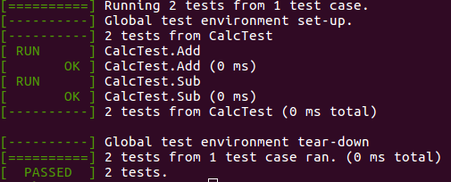

Conclusion
During software development life cycle is very important to write test code to verify the correctness of production code, paving the way to improve the code quality, developer’s confidence when refactoring etc. In this context, tools for automatic unit testing can help in the process and they can be integrated with a Continuous Integration (CI) server to be executed automatically for each commit.
In a future post, I intend to talk more about unit testing and the software development methodology denominated Test Driven Development (TDD), which changes the “conventional” process from: Code -> Test, to: Test -> Code.

References
[1] https://github.com/google/googletest#Assertions
[2] https://www.eriksmistad.no/getting-started-with-google-test-on-ubuntu/

Introduction to Google c++ testing framework

https://shubhrasuman.medium.com/introduction-to-google-c-testing-framework-aa90552be802
Shubhra Suman
Nov 11, 2020
Hey there!,
Let’s get started with Google Testing Framework for C++ known as Google test.

GTest: (Google Unit Testing)
Google test is a unit test framework based on xUnit architecture. Basically, you’ll write a test program, containing many test cases and will check it against your program after compiling Google test into a library.

Why we use GTest?
- It is portable and reusable so the same test case can be used for Linux, Windows, MAC.
- It doesn’t terminate if one test case fails instead it will halt that test case and will continue to execute for other cases.

Basic concepts
When we are using google test, we can start by writing assertions, which are statements that check whether a condition is true or false.
Assertions can be of three types:
- Success
- Non-fatal failure
- Fatal failure
In case of fatal failure, the execution of the test code stops at that place whereas in case of non-fatal failure the execution of the test code does not stop.
A test suite contains one or more tests. You should group your tests into test suites that reflect the structure of the tested code. When multiple tests in a test suite need to share common objects and subroutines, you can put them into a test fixture class.

Assertions
Assertions are macros that resemble function calls. You test a class or function by making assertions about its behavior. When an assertion fails, google test prints the source file, line number along with failure message.
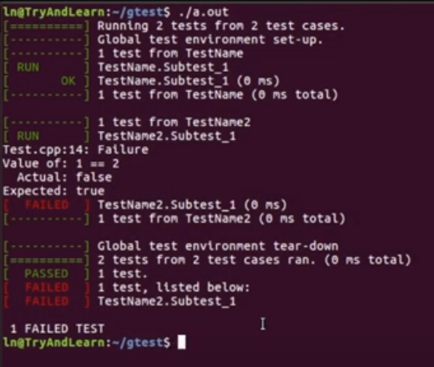
ASSERT_* generates fatal failure so when they fail they abort the current function whereasEXPECT_* are non-fatal failure. However, you should use ASSERT_* if it doesn't make sense to continue when the assertion in question fails.

Binary Comparison
Value in the argument should be comparable or else we will get a compiler error.
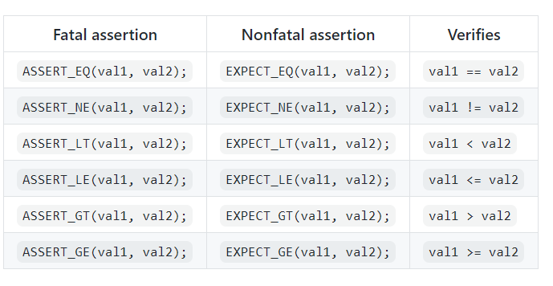

String Comparision
It compares two strings.
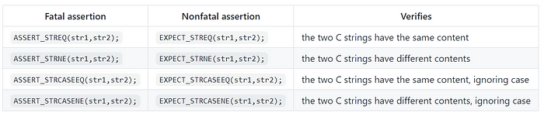
NOTE: The CASE in assertion and expect means ignore case.

Create tests
- We will use TEST() a macro to define and name a test function. These functions don't have a return type.
- In the function, we can use various google test assertion functions to test values.
- The test result is determined by assertions if an assertion test case fails or crashes then the entire test fails.
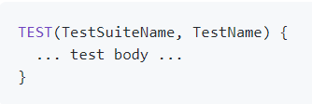
TEST( ) contains two arguments. The first is the Test suite name and the second one is the test’s name within the test suite.
NOTE: Both arguments should be a valid c++ identifiers and must not contain underscores.
For example:
int factorial(int n); //return factorial of a number
Let’s design test suite for this function
Test(FactorialTest, HandlesZeroInput)
{
EXPECT_EQ(factorial(0),1);
}
Test(FactorialTest, HandlesPostiveInput)
{
EXPECT_EQ(factorial(1),1);
EXPECT_EQ(factorial(2),2);
EXPECT_EQ(factorial(3),6);
}

GTest Framework
https://www.geeksforgeeks.org/gtest-framework/

What is Googletest?
- It is a test framework i.e., a software tool for writing and running unit tests.
- It is a library for writing C++ tests.
- It is based on xUnit architecture which is a set of “Frameworks” for programming and automated execution of test cases.

Why Googletest?
- Googletest helps us to write better C++ tests.
- Independent and Repeatable: Googletest isolates the tests by running each of them on a different object.
- Portable and Reusable: Googletest works on different Oses (Linux, Windows, or a Mac), with different compilers.
- When tests fail, it should provide as much information about the problem as possible.

Nomenclature:
- TestSuite:It is used for grouping related tests.
- TEST(): It exercises a particular program path with specific input values and verify the result.
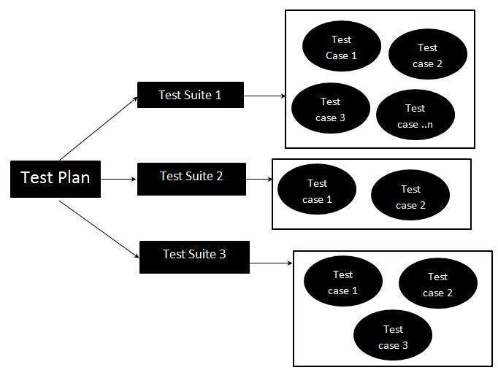

Basic Concepts:
- Assertions:
  - A statements that check whether a condition is true.
  - Output: success, nonfatal failure, or fatal failure(aborts the current function).
- Test fixture class:
  - Collection of multiple tests in a test suite that need to share common objects and subroutines.
In below lines * represent multiple character such as EQ / NE / LT / LE / GT / GE.
- ASSERT_*: Generate fatal failures when they fail, and abort the current function immediately. (possibly skipping clean-up code that comes after it, it may cause a space leak).
- EXPECT_*:Generate nonfatal failures, which don’t abort the current function.
- Examples:
  - ASSERT_EQ, ASSERT_NE, ASSERT_LT, ASSERT_GT, ASSERT_GE.
  - EXPECT_WQ, EXPECT_NE, EXPECT_LT, EXPECT_GT, EXPECT_GE.
Fatal assertion | Nonfatal assertion | Verifies
ASSERT_TRUE (condition); | EXPECT_TRUE (condition); | condition is true
ASSERT_FALSE (condition); | EXPECT_FALSE (condition); | condition is false
ASSERT_STREQ(str1, str2); | EXPECT_STREQ(str1, str2); | the two string str1 and str2 have the same content
ASSERT_STRNE(str1, str2); | EXPECT_STRNE(str1, str2); | the two strings str1 and str2 have different content
ASSERT_STRCASEEQ(str1, str2); | EXPECT_STRCASEEQ(str1, str2); | the two string str1 and str2 have the same content, ignoring the case
ASSERT_STRCASENE(str1, str2); | EXPECT_STRSTRCASENE(str1, str2); | the two strings str1 and str2 have different content, ignoring the case

Simple tests:

TEST():
- A macro to define and name a test function.
- Use the various Googletest assertions to check values.
- If any assertion in the test fails (either fatally or non-fatally), or if the test crashes, the entire test fails. Otherwise, it succeeds.
TEST(TestSuiteName, TestName) {
... test body ...
}

Test Fixtures:
- Using the Same Data Configuration for Multiple Tests.
- Derive a class from ::testing::Test. Start its body with protected:, as we will want to access fixture members from sub-classes.
- If necessary, write a default constructor or SetUp().
- If necessary, write a default destructor or TearDown().
- Use TEST_F(), instead of TEST().
TEST_F(TestFixtureName, TestName) {
... test body ...
}

Invoking the Tests:
- RUN_ALL_TESTS();
  - Returns 0: All tests are successful.
  - Returns 1: otherwise.

Examples:
A factorial function:
int factorial(int n)
{
// If n < 1;
return -1;
// Else factorial = n!;
return factorial;
}
TEST(FactorialTest, FactorialOfZeroShouldBeOne)
{
ASSERT_EQ(1, factorial(0));
}
TEST(FactorialTest, FactorialOfPositiveNos)
{
ASSERT_EQ(1, factorial(1));
ASSERT_EQ(24, factorial(4));
ASSERT_EQ(120, factorial(5));
}
int main(int argc, char **argv)
{
testing::InitGoogleTest(&argc, argv);
return RUN_ALL_TESTS();
}

Command Line Arguments:
- Dump the output into XML format by passing: –gtest_output=”xml:report.xml”
- If want to run multiple times: –gtest_repeat=2
- Debugger invoked on failure: –gtest_break_on_failure
- Not all the tests needs to be run all the times: –gtest_filter=<test string>
Whether you're preparing for your first job interview or aiming to upskill in this ever-evolving tech landscape, GeeksforGeeks Courses are your key to success. We provide top-quality content at affordable prices, all geared towards accelerating your growth in a time-bound manner. Join the millions we've already empowered, and we're here to do the same for you. Don't miss out - check it out now!

C++ TUTORIAL - GOOGLE TEST (GTEST)
https://www.bogotobogo.com/cplusplus/google_unit_test_gtest.php

Google Unit Test (GTest)
The Framework of Google C++ Testing is based on xUnit architecture. It is a cross platform system that provides automatic test discovery. In other words, we don't have to enumerate all of the test in our test suite manually. It supports a rich set of assertions such as fatal assertions (ASSERT_), non-fatal assertions (EXPECT_), and death test which checks that a program terminates expectedly.
Here is the Primer.
GTest also provides various options for running tests and offers textual and XML report. It also supports a mock object testing framework (Google Mock).
Initially, we have a project calculating a cubic:
// simplemath.h

#include <cmath>

double cubic(double d)
{
return pow(d,3);
}

// SimpleMath.cpp : Defines the entry point for the console application.
#include "simplemath.h"

int main()
{
cubic(10);
return 0;
}
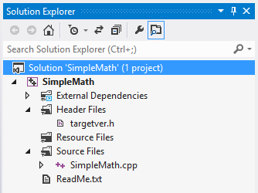
In the following example, we used Visual Studio 2012 with 4 steps:
- Download Google test
- Compile gtest into a static library
- Create a unit test project
- Make a test case
Step 1. Download Google test (gtest)
Download the gtest-1.7.0-rc1.zip from Google C++ Unit Test or from gtest-1.7.0-rc1.zip, then extracts it.
Let's look at the C:\GTEST\gtest-1.7.0 directory to see what files are there.
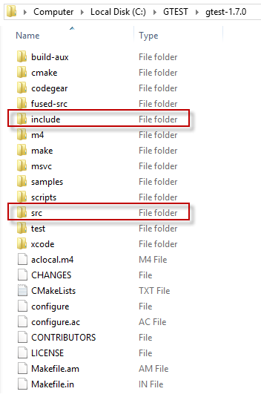
The src folder has all the gtest source files and later we need to add the include directory to the include path.

Step 2. Compile gtest into a static library
- Create a new static library project with a name GoogleTest.
Add->New Project->Win32 Project->Static Library without precompiled header.
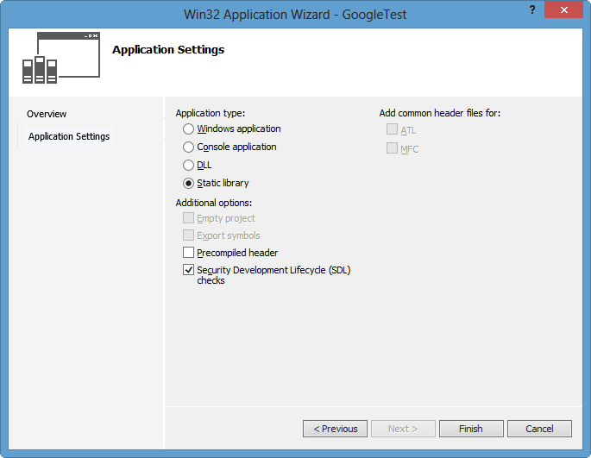
- Right click on our new project, GoogleTest.
On the Properties Pages, add include path:
C:\GTEST\gtest-1.7.0 and C:\GTEST\gtest-1.7.0\include.
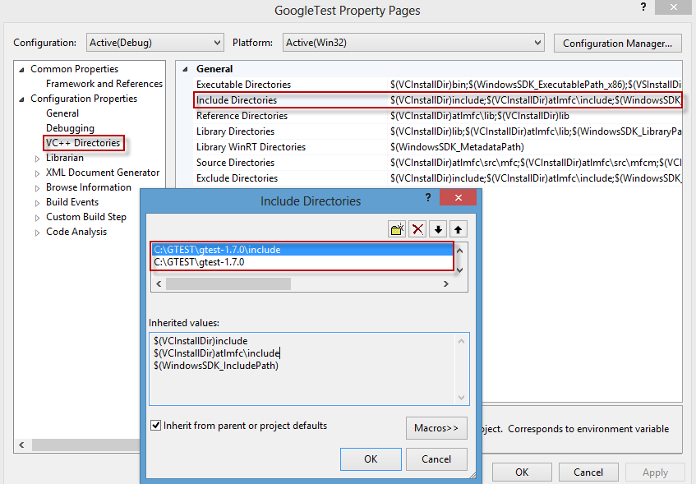
- Add source files by Add->Existing Item...
C:\GTEST\gtest-1.7.0\src\gtest_all.cc
and C:\GTEST\gtest-1.7.0\src\gtest_main.cc.
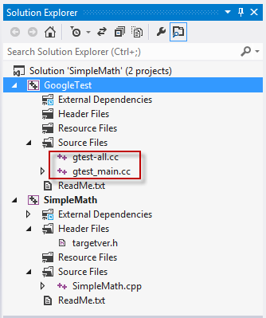
Build GoogleTest into static library.
In the build process, we may have some errors related to class template:
VC++ 2012 does not (and will never) support variadic templates; consequently, its
standard library implementation attempts to fake them using preprocessor-generated overloads and specializations. The number of faux variadic template parameters defaults to 5 - the problem is that gtest is trying to instantiate std::tuple<> with as many as 10 template arguments. - Google Test in Visual Studio 2012.
So, we need to set _VARIADIC_MAX=10 for Preprocessor Definitions under C/C++.
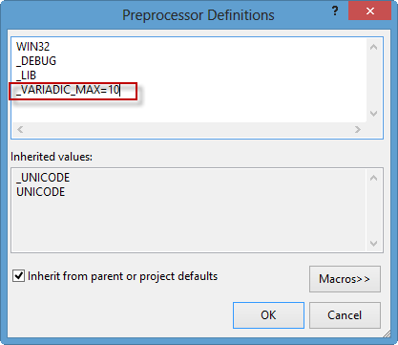
Now, build it again:
1>------ Rebuild All started: Project: GoogleTest, Configuration: Debug Win32 ------
1> gtest_main.cc
1> gtest-all.cc
1> Generating Code...
1> GoogleTest.vcxproj -> c:\users\khyuck\documents\visual studio 2012\Projects\SimpleMath\Debug\GoogleTest.lib
========== Rebuild All: 1 succeeded, 0 failed, 0 skipped ==========

Step 3. Create a unit test project
Now, it's time to create a unit test project.
- Right click on Solution->Add->New Project with a name unittest_SimpleMath as a Win32 Console. We've just added 3rd prodject to our solution:
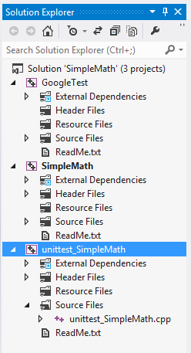
- We need to add the two paths as we've done in Step 2:
Right click on our new project, unittest_SimpleMath.
On the Properties Pages, add include path:
C:\GTEST\gtest-1.7.0 and C:\GTEST\gtest-1.7.0\include.
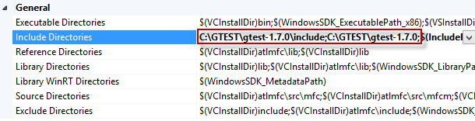
- This project needs additional path to the initial project (SimpleMath) which we want to be tested.
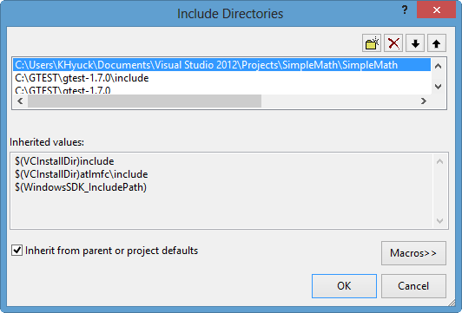
- Let's add new references (GoogleTest and SimpleMath) to unittest_SimpleMath.
Right click on unittest_SimpleMath->References...
Under Property Pages->Add New References...
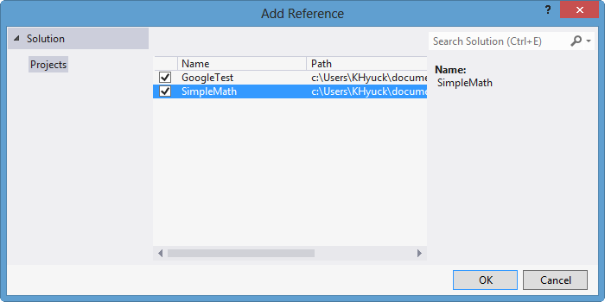
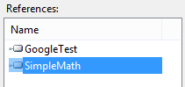
- Great. Our Unit Test project has been set up.
Final step will be making a test case.

Step 4. Create a Test Case
Now, we need to create a test case.
Type in the following lines of code:
// unittest_SimpleMath.cpp : Defines the entry point for the console application.

#include "gtest/gtest.h"
#include "simplemath.h"

TEST(testMath, myCubeTest)
{
EXPECT_EQ(1000, cubic(10));
}
Here, we're testing the cubic() function we wrote before, and it compares the output of 10^3 with 1000 using macro EXPECT_EQ.
If we run the unittest_SimpleMath, we get the test result:
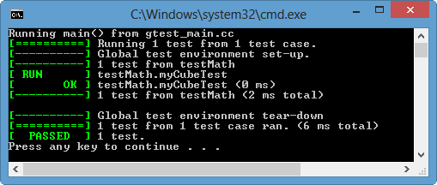
OK!
We passed our first Google Test!

